Potential distribution of Festuca gautieri in Victoria

Species: Festuca gautieri (Hackel) K. Richter
Common name: bearskin fescue
Status: State Prohibited Weed

Habitat:
Native habitat; rocks and scrub sub-alpine regions NE Spain and SW France. Occurs in both moist (mesic) and dry (xeric) environments with preference for dry situations. Requires an open, sunny, cool location. Not known to be naturalised in Australia yet, but promoted as an attractive ornamental grass. Known on limestone quarry in Northwest Yorks (Britain).

Potential distribution produced from CLIMATE modelling overlayed on suitable landuse and broad vegetation type map layers, with CMA boundaries
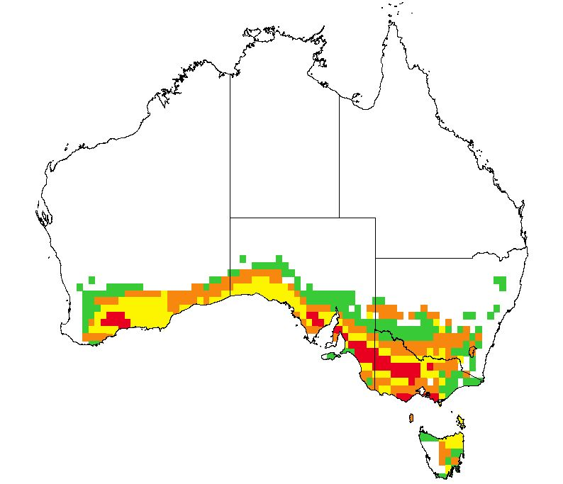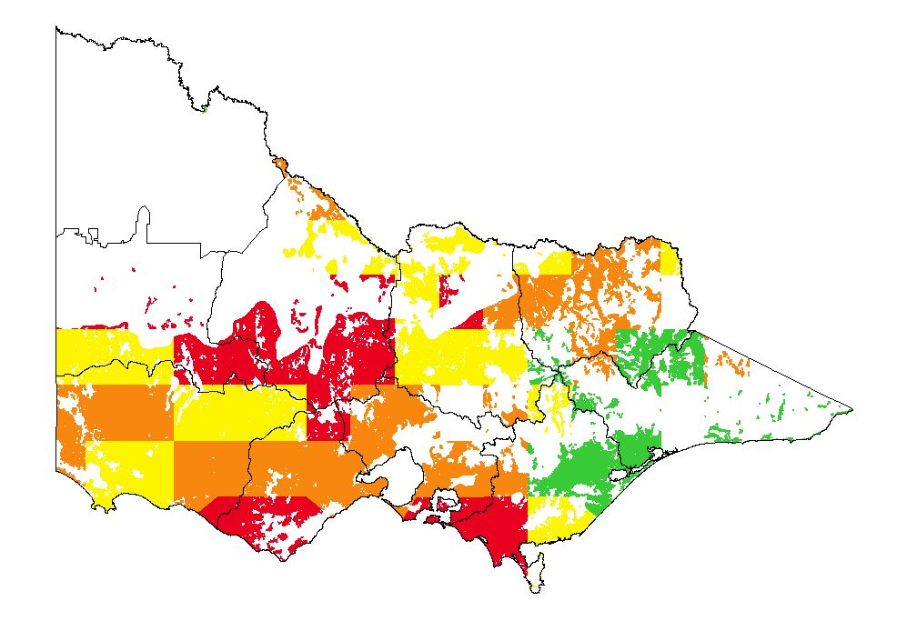
Map Overlays used.
Land Use:
Pasture irrigated Pasture dryland

Broad vegetation types
Sub-alpine woodland, sub-alpine grassy woodland, montane grassy woodland, montane dry woodland, inland slopes woodland, grassland, plains grassy woodland, coastal grassy woodland, coastal scrubs.

Colours indicate possibility of Festuca gautieri infesting these areas.
 | Red | = Very high |  | Yellow | = High
 | Orange | = Medium |  | Green | = Likely

In the non-coloured areas the plant is unlikely to establish as the climate, soil or landuse is not presently suitable.

