Present distribution of Acacia nilotica ssp. indica in Victoria
Scientific name: | Acacia nilotica ssp. indica L.
Common name(s): | Prickly acacia
Status:
Habitat:
Prefer tropical and subtropical climates. Found in woody grasslands and savannas. In northern Australia, found in Mitchell grasslands. Occurs on a wide range of soil types (DNRE 2004).

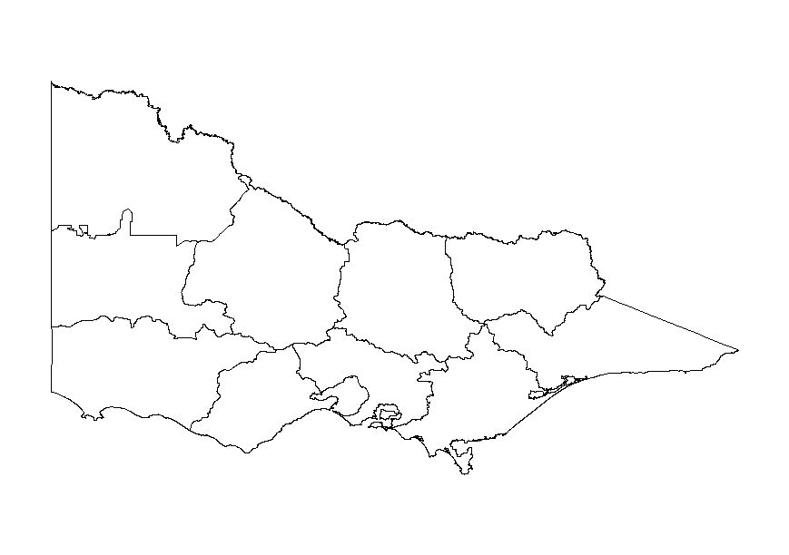
Not known as naturalised in Victoria.
Not known as naturalised in Victoria.

