Present distribution of Mimosa pigra in Victoria
Scientific name: | Mimosa pigra L.
Common name(s): | mimosa, giant sensitive plant
Status:
Habitat: Favours wet-dry tropical climate with annual rainfall between 750 and 2250 mm. Found most commonly in floodplains and riverbanks within soils ranging from black cracking clays to sandy clays to coarse siliceous sand although does not appear to grow preferentially in any soil type. Occurs in agricultural areas, coastland, disturbed areas, natural forest, planted forests, range/grasslands, riparian zones, scrub/shrublands, urban areas, water courses, wetlands. (ISSG 2005). Wet places in the humid and subhumid tropics, occurring as a weed of roadsides, watercourses, drainage ditches, reservoirs, seasonally flooded wetlands, lowland fields and occasionally tropical mountain valleys (Parsons & Cuthbertson 2001).
soil or landuse is not presently suitable.
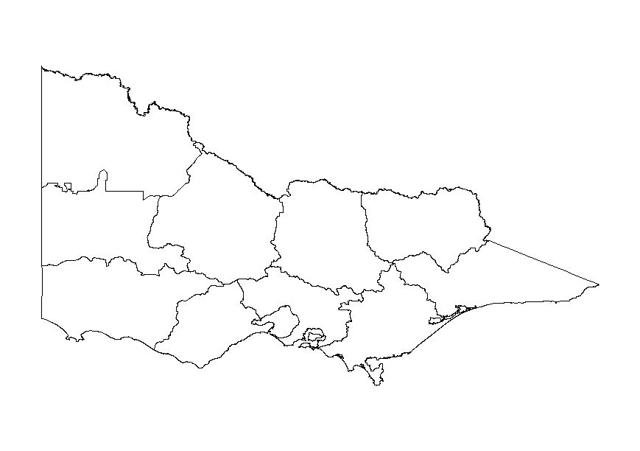
Not known as naturalised in Victoria.

