Potential distribution of Tipuana tipu in Victoria
Scientific name: | Tipuana tipu (Benth.) Kuntze
Common name(s): | rosewood, tipuana tree
Status:
Habitat: Native to southern Bolivia and northern Argentina. Common in gallery forests of the Andes, found in both valleys and mountain forests up to 2900 m. Grows under a wide range of climatic conditions and tolerates a variety of soils although prefers soils with good drainage. Grow on foothills and borders of dry farming lands (Cruz et al 2002). Grows in subtropical environment with warm year-round temperatures in native range. Grows well in moist conditions and will survive temperatures to minus 6.5°C. Invades disturbed sites such as roadsides and creekbanks, also grows in woodland and open grassland areas with an absence of grazing (CRC for Australian Weed Management 2003).
Potential distribution produced from CLIMATE modelling refined by applying suitable landuse and vegetation type overlays with CMA boundaries
Map Overlays used.
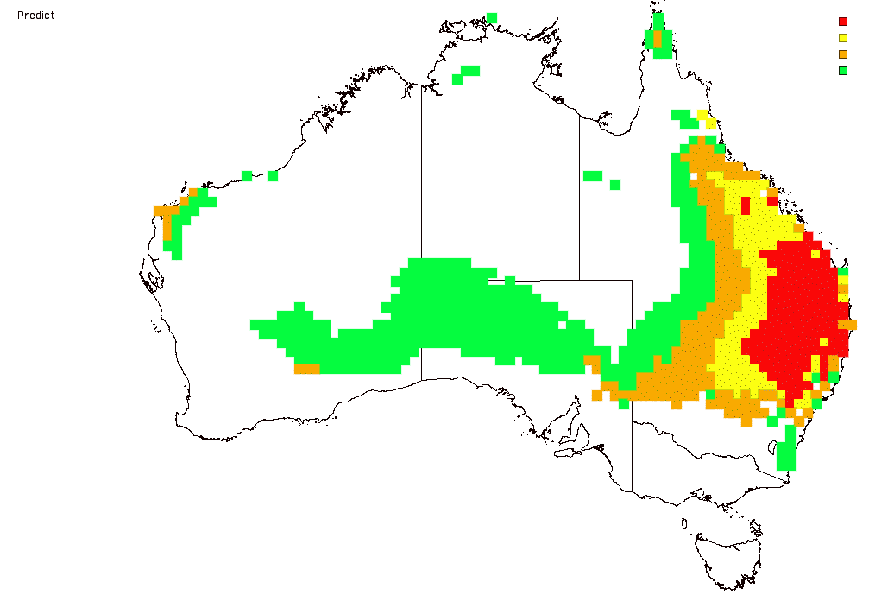

Land Use:
Pasture dryland
Pasture irrigation

Broad vegetation types
Montane moist forest; grassland; riverine grassy woodland; riparian forest

Colours indicate possibility of Tipuana tipu infesting these areas.
 | Red | = Very high |  | Yellow | = High
 | Orange | = Medium |  | Green | = Likely
In the non-coloured areas the plant is unlikely to establish as the climate, soil or landuse is not presently suitable.

